Design Patterns:

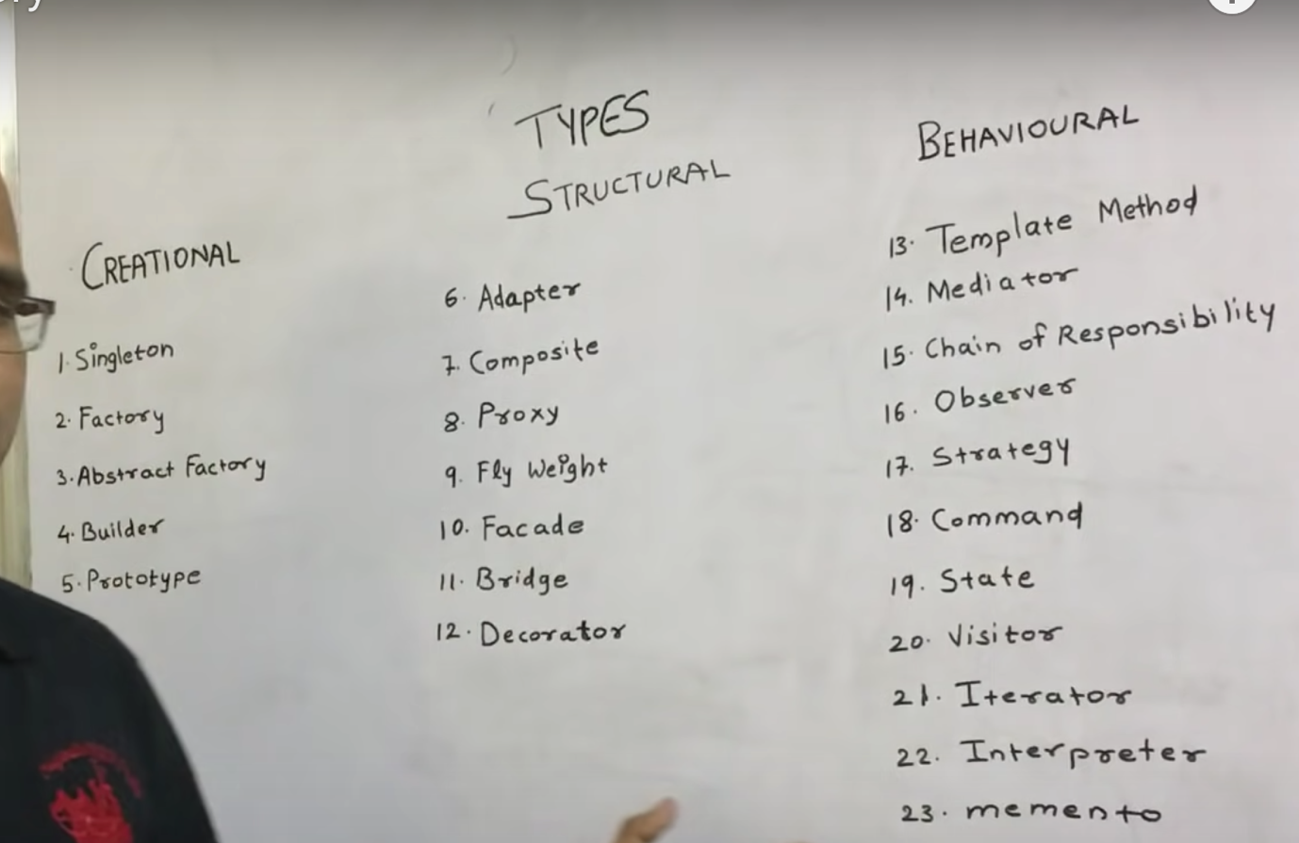

Creational:

If we want to create object, we should use creational design pattern.

Structural:

If we want to compose object i.e., if we want to use one object in other object then we have to use structural design pattern.

Behavioral:

If we want to make communication bw the objects we have to use behavioral pattern.

Factory design pattern:

We use this pattern for loose coupling. We also use this pattern to hide the class names for the client.

Builder design pattern:

We use this pattern to initialize the properties of an object.

Ex:
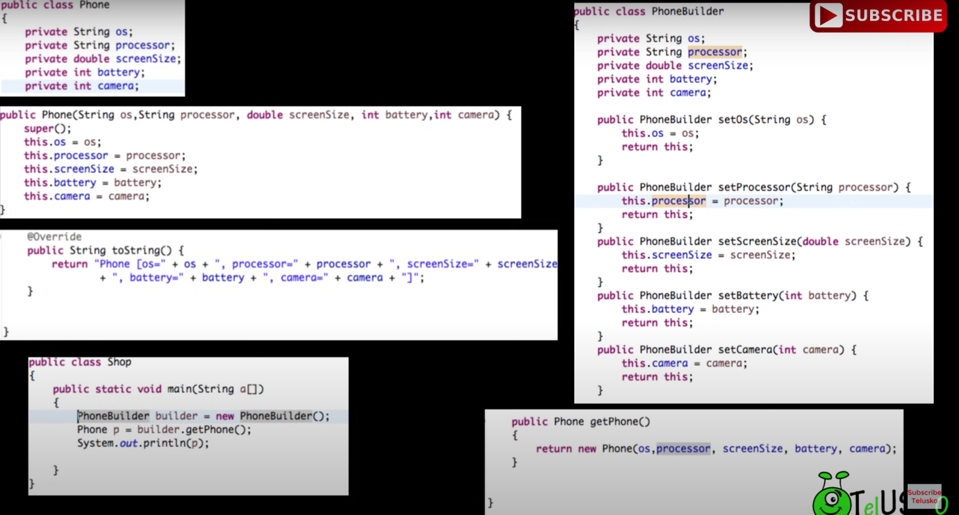

Adapter Design Pattern:

Adapter is used to combine the implementation of two classes. Here we have an interface which will be implemented by adapter class. In the adapter class we override the interface with the implementation we want.

